Department | AIML
Course Code / Course Name | DSA0602/ Data Handling and Visualization
Experiment | Data Visualization using R
Name | YASHIKA.R
Register Number | 192525102
Date | 15/10/2026
Day | Thursday
Set 23: Employee Performance Analysis

1. Bar chart of employees by department
Aim: To visualize the number of employees in each department.
Algorithm:
- Create the employee dataset.
- Count employees in each department.
- Plot the department counts as bars.
- Add a title and axis labels.
Code:
library(ggplot2)
employees <- data.frame(
Employee_ID = 1:5,
Department = c("Sales", "HR", "Marketing", "Sales", "HR"),
Years_Service = c(5, 3, 7, 4, 2),
Performance_Score = c(85, 92, 78, 90, 76)
)

write.csv(employees, "employee_performance.csv", row.names = FALSE)

ggplot(employees, aes(x = Department, fill = Department)) +
geom_bar() +
labs(title = "Employees by Department",
x = "Department", y = "Number of Employees") +
theme_minimal()
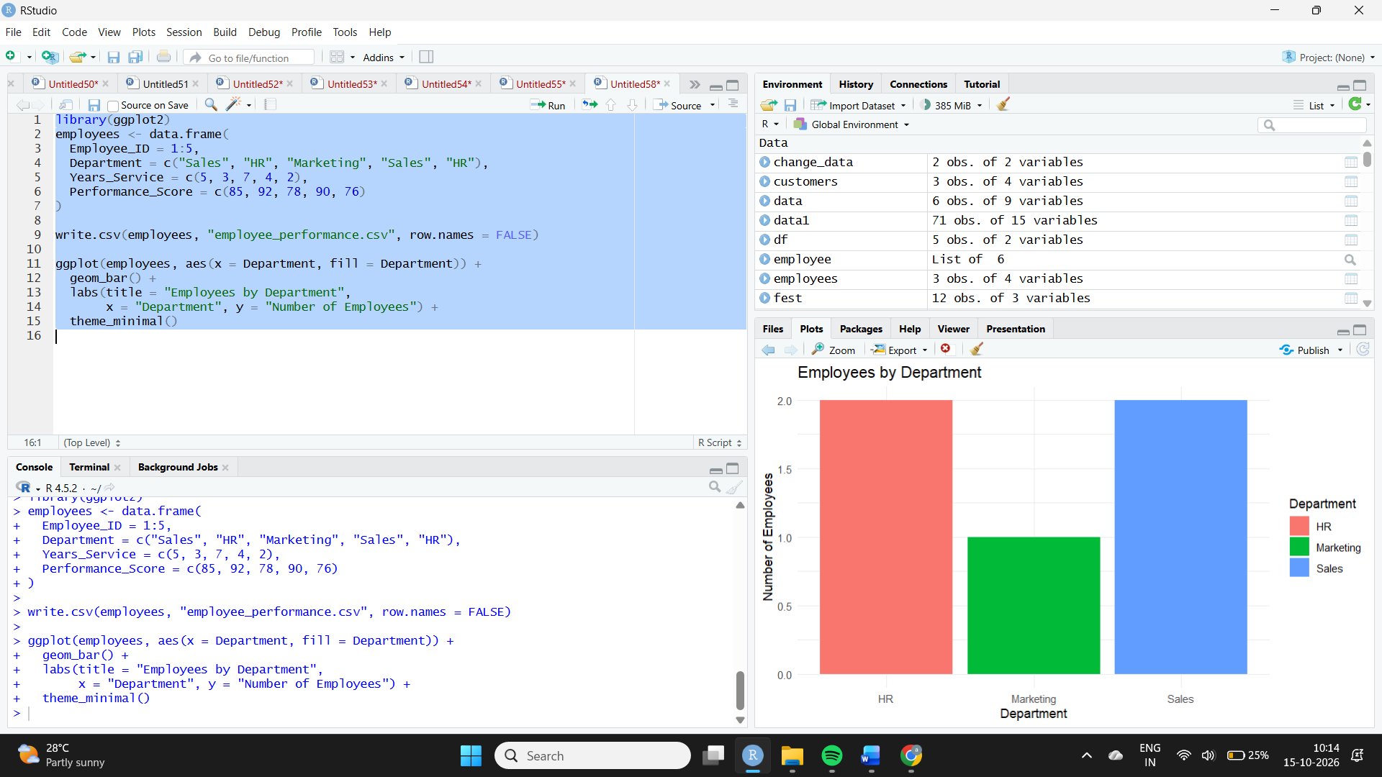
Observation: Sales and HR each have 2 employees, while Marketing has 1 employee. Sales and HR are tied for the highest employee count.
2. Line chart of employee performance
Aim: To visualize performance scores in relation to years of service.
Algorithm:
- Load the employee dataset.
- Sort the records by years of service.
- Plot years of service against performance score.
- Add points, connecting lines, a title and axis labels.

Code:
library(ggplot2)
employees <- data.frame(
Employee_ID = 1:5,
Department = c("Sales", "HR", "Marketing", "Sales", "HR"),
Years_Service = c(5, 3, 7, 4, 2),
Performance_Score = c(85, 92, 78, 90, 76)
)
employees <- employees[order(employees$Years_Service), ]
ggplot(employees, aes(x = Years_Service, y = Performance_Score)) +
geom_line(color = "blue") +
geom_point(size = 3) +
labs(title = "Performance Score by Years of Service",
x = "Years of Service", y = "Performance Score") +
theme_minimal()
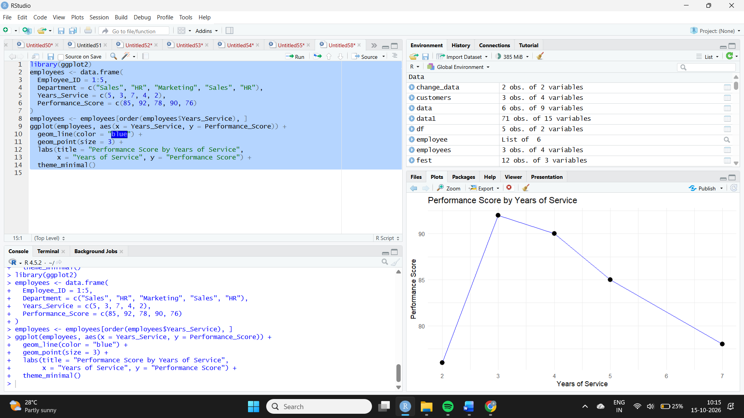
Observation: Performance scores vary across employees. The employee with 3 years of service scored 92, while the employee with 7 years scored 78. The small dataset does not demonstrate that performance necessarily increases with service.
3. Tableau dashboard
Aim: To combine department-wise employee counts and a scatter plot of years of service versus performance scores.
Algorithm:
- Import the employee CSV file into Tableau.
- Create a bar chart of employee counts by department.
- Create a scatter plot of years of service against performance score.
- Add both charts to a dashboard.
- Add filters and labels for interactive analysis.
Procedure:
- Drag Department to Columns and Employee ID to Rows; change aggregation to Count.
- Create another sheet with Years of Service on Columns and Performance Score on Rows.
- Drag Employee ID to Detail to display each employee separately.
- Add both sheets to a dashboard and give it a title.
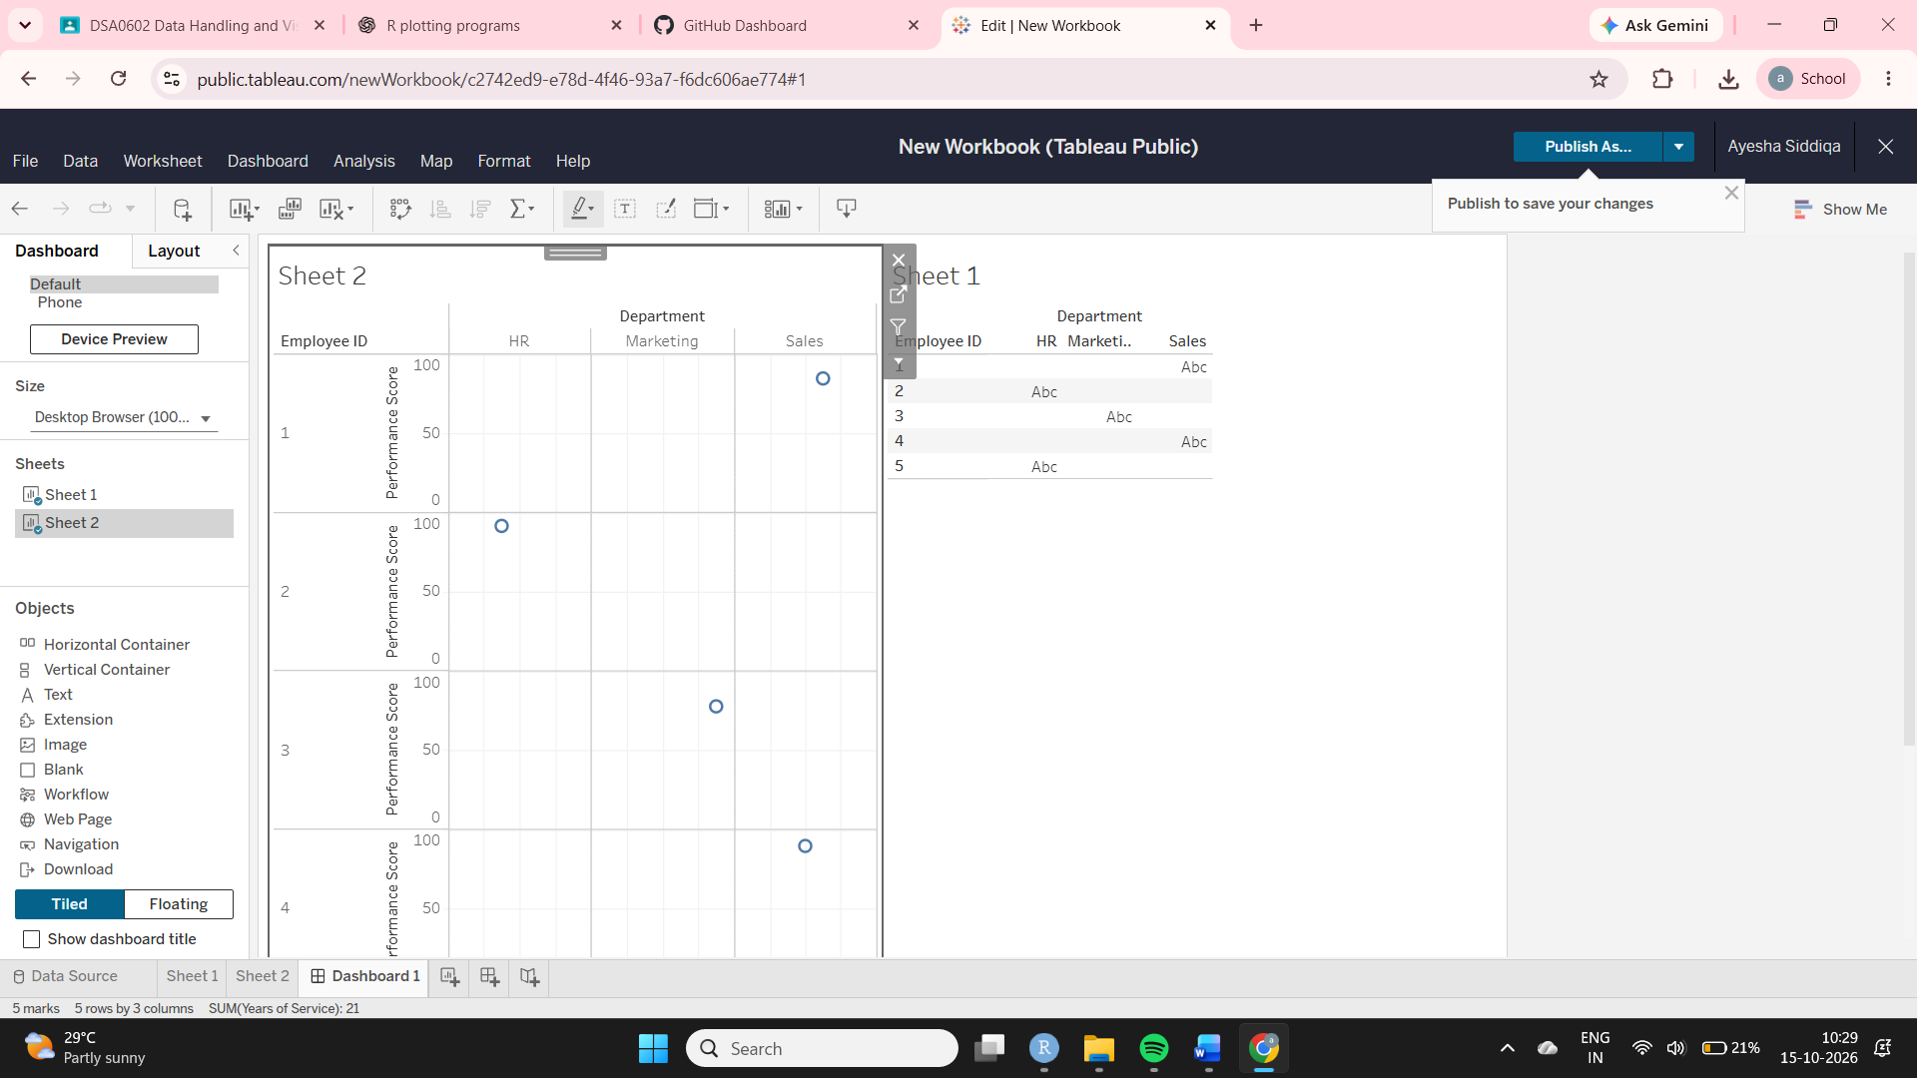
Observation: The dashboard shows that Sales and HR have the largest department counts, with 2 employees each. The scatter plot shows individual employee performance scores in relation to service length.
4. Employee performance table
Aim: To display employee performance information in a structured table.
Algorithm:
- Create the employee dataset.
- Select the required columns.
- Display the table.
- Save the table as a CSV file.
Code:

employees <- data.frame(
Employee_ID = 1:5,
Department = c("Sales", "HR", "Marketing", "Sales", "HR"),
Years_Service = c(5, 3, 7, 4, 2),
Performance_Score = c(85, 92, 78, 90, 76)
)

write.csv(employees, "employee_performance_table.csv", row.names = FALSE)
print(employees, row.names = FALSE)

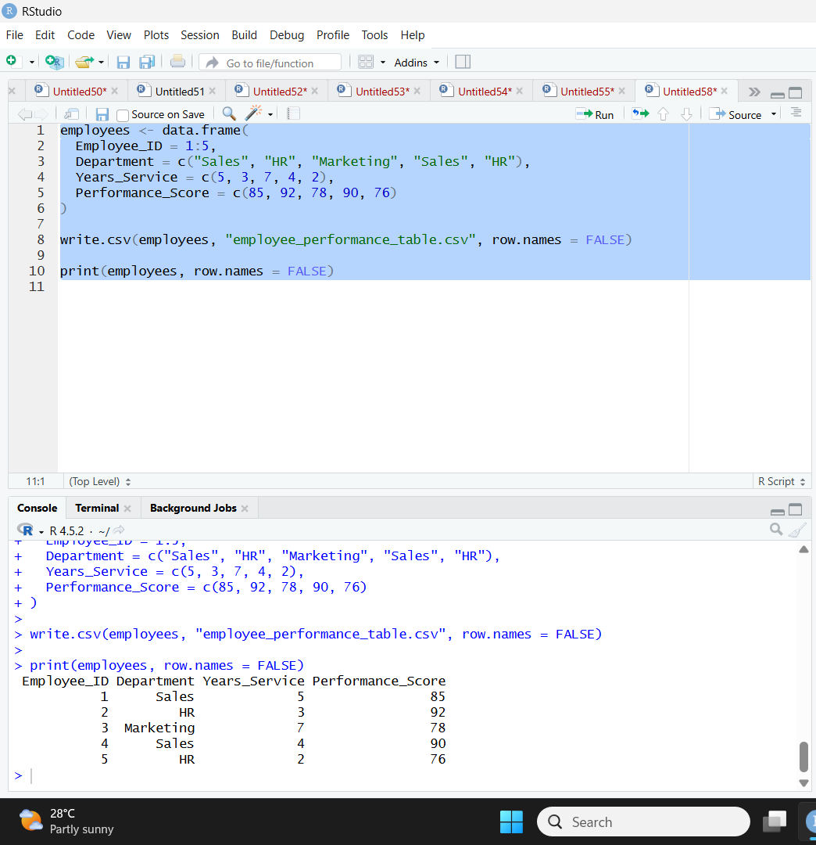
Observation: The table displays five employees with their department, years of service and performance score. Employee 2 has the highest score of 92, while Employee 5 has the lowest score of 76.

